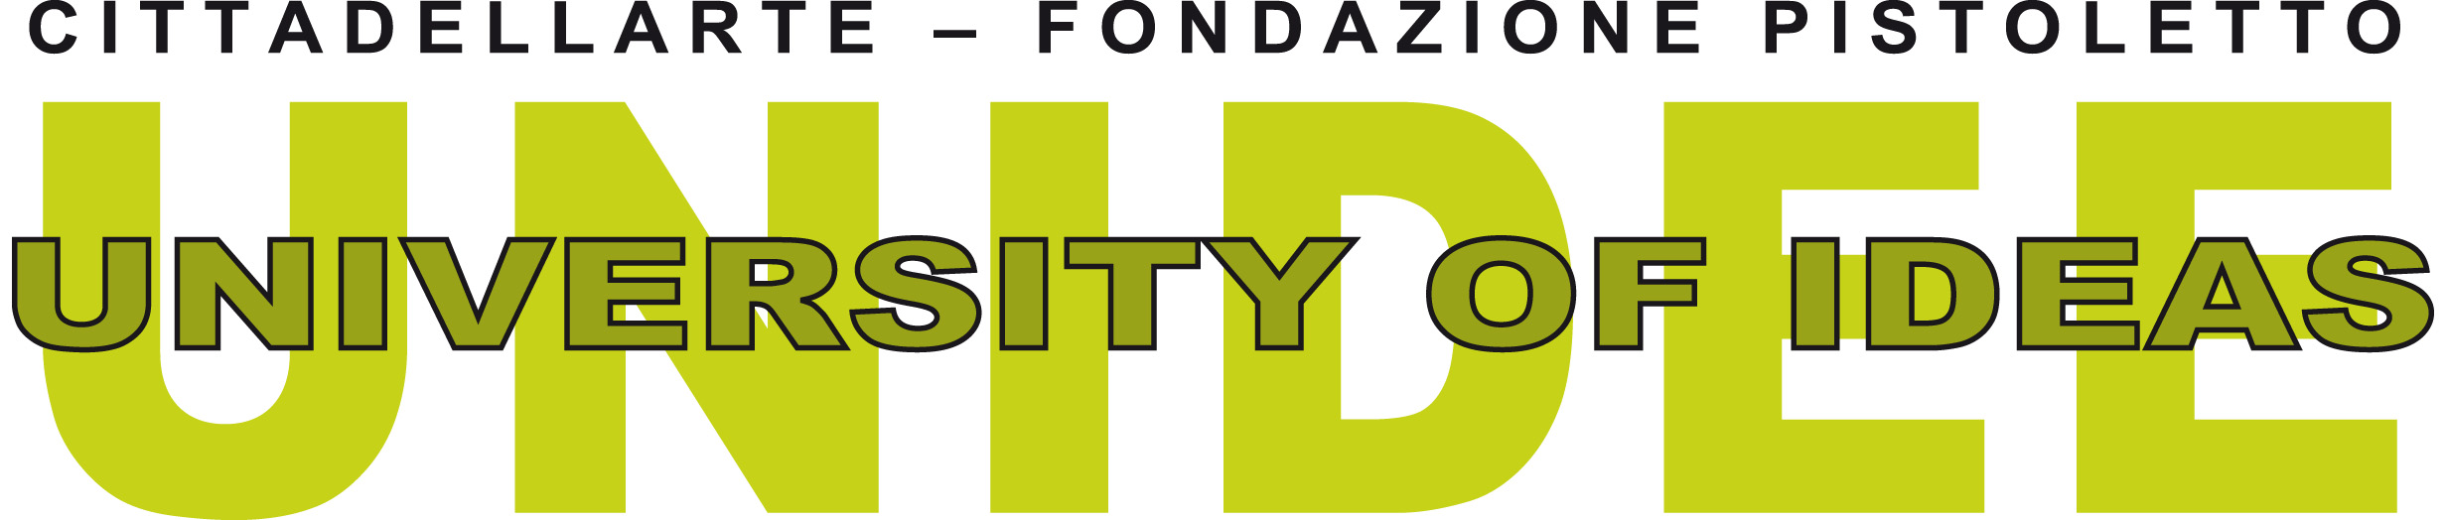

CALL FOR APPLICATIONS FOR A RESIDENCY GRANT
at UNIDEE – University of Ideas
Cittadellarte – Fondazione Pistoletto in Biella, Italy
Residency period: 30th September – 30th November, 2019

Launched by Michelangelo Pistoletto in 1999, UNIDEE is the higher educational programme for art and social change of Cittadellarte – Fondazione Pistoletto. Weaving together moments of interdisciplinary research, knowledge sharing and practical activities, the objective of the programme is to provide the participants with inspiration, motivation and instruments to activate or develop artistic initiatives based on the engagement of local ecologies. Open to artists and professionals from all over the world through residential dynamics, the programme intends to form “artivators”, i.e. people working at the boundaries between artistic practices, processes of social change and collaborations with communities outside the art world.
UNIDEE started as a four-month international residency programme (1999 – 2013), to enhance its model in 2015 by focusing on annual themes and developing three formats: UNIDEE Modules, UNIDEE AIR – Emerging Geographies and the UNIDEE Connective Residency.
UNIDEE Modules are intensive weekly residential modules open to students, professionals, activists and members of the civil society. They are led by artist-mentors with the support of guests coming from other disciplines, for groups of 10 to 12 participants.
UNIDEE AIR – Emerging Geographies is the international artists residency program organised in partnership with other art institutions, with the aim of supporting the practice of artists coming from non-Western countries. Every year four international artists stay in residence for eight weeks at Cittadellarte with the aim of entering in contact - though meetings, studio visits and travels in other cities – with the Italian cultural scene, and deepen their research interests.
Launched in 2015, the UNIDEE Connective Residency programme is revolved to Italian artists with the aim of connecting their work with the local context of Biella. Every year for a period of six months, an artist selected by direct invitation, is invited to produce a new piece exploring and expanding the themes of social responsible transformation considering the local context of Biella as a starting point of research

I. ABOUT THE RESIDENCY
A 2 month long educational residency programme based on the relationship between participatory art practices and socio-political transformation of society.

The 2-month residency programme will revolve around the UNIDEE Fall Term programme titled Modes of Instituting which aims at investigate how artists are currently engaged in stretching the very notion of artistic practice beyond the dominant model of art making (Jason E. Bowman, 2016), to invent new organizations that expand art’s intervention into society. We refer to this methodology as instituting – i.e. the process of institution building as a cultural and critical act. At Cittadellarte the act of instituting responded to four principles: engaging in long terms projects, promoting social critique, favouring collective participation on local scale, and endorsing multidisciplinary discussion.

The Fall Term is dedicated to imagine the role of art organizations in times of perennial crisis, and to discuss what would be their future(s) in the next coming twenty years. A group of eight international applicants will be selected to follow a two months program of workshops and conferences. Artists and curators that gave life to emergent institutional models and art organizations will be invited as Visiting Professors to share their experiences and concerns.

The final aim of the term will be to write, all together, an ethical charter of how contemporary art organizations should work as places for political agency, community building and social change.

The 2-month long residency offered through this joint grant (YARAT Contemporary Art Space & Cittadellarte – Fondazione Pistoletto) includes:

- Return travel from Azerbaijan to Biella, Italy;
- Visa reimbursement;
- 2 months' stay at Cittadellarte – Fondazione Pistoletto (single room in an apartment shared with other international residents – inclusive of cleaning services, use of shared studio space and workshop facilities);
- Insurance (travel and medical insurance for accidents);
- Expert visits, networking sessions, institutional visits, visits to museums and galleries, and travel within Northern Italy (e.g. Milan, Turin and Venice);
- A small budget for production, communication and translations;
- A modest per diem (600 €);
- Participation in all the weekly residential modules scheduled during Fall session of UNIDEE 2019 (names and texts announced in June).

II. ELIGIBILITY CRITERIA
You are eligible to apply if (all conditions below must be met):
- You are a citizen of Azerbaijan;
- You currently reside in the country;
- You were born during or after 1982;
- You have not previously received grants from YARAT Contemporary Art Space for overseas projects;
- You have a fluent knowledge of the English language.
Preference will be given to artists who are managing independent / own spaces or who have a strong interest in the subject “Modes of Instituting”.

PLEASE NOTE that the residency dates are fixed and no change can be accepted. Once the artist signs the agreement, it is mandatory to respect the given dates.

Deadline for submissions: Sunday 30th June, 2019.
Only digital submissions are accepted.

III. SELECTION PROCEDURE

YARAT Contemporary Art Space will prepare an initial short-list of candidates, amongst whom UNIDEE's curatorial board will select one residency grant winner.

Final results will be released by Friday 19th July, 2019.

IV. HOW TO APPLY

Please submit your applications to: residencies@yarat.az with “YARAT/UNIDEE application (your name)” as a subject line (Up to 8 MB per email).

Please fill out (in English only) this application form by including your:

- Basic / contact information;
- Motivation letter, including a project proposal for this specific residency (up to 1000 words). In writing up your proposal, bear in mind that UNIDEE Fall Term will focus its research on the theme Modes of Instituting. The project you are proposing at the time of your application is not binding and can be implemented while in residence if still relevant.
- Artist statement;
- Curriculum Vitae;
- A selected portfolio (max 3 projects, one single PDF, max 6 MB)

V. APPLICATION FORM

First name:
Last name:
Gender:
Date of birth:
Place of birth:
Nationality:
Address:
Passport n°:
Telephone:
Email:
Website:

Motivation letter for this specific residency:
(The boxes will expand according to the size of the text inserted)

Artist statement:

I confirm this information as correct. I have also submitted my CV and relevant documentation of my work in a selected portfolio.

I am aware that UNIDEE – University of Ideas, Cittadellarte – Fondazione Pistoletto and YARAT Contemporary Art Space will publish the names and projects of the successful applicants in various publications such as on their websites, newsletters and annual reports.

If my application is successful, I agree to use the residency and grant provided in an appropriate and responsible manner.

Name:

Place and date:

